**A Project Report on**

**“ONLINE RENTAL SYSTEM”**

**Submitted in partial fulfillment of the requirement for**

**Degree in Bachelor of Engineering (Information Technology)**

**By**

Ayrin George (501609)

Tanvi Dhakate (501612)

Olivia Biswas (501638)

**Guided by:**

**Prof. Kalpana Wani**



**Department of Information Technology**

**Fr. Conceicao Rodrigues Institute of Technology**

Sector 9A, Vashi, Navi Mumbai – 400703

**University of Mumbai**

**2019-2020**

**CERTIFICATE**

This is to certify that the project entitled

**ONLINE RENTAL SYSTEM**

**Submitted By**

Ayrin George

Tanvi Dhakate

Olivia Biswas

In partial fulfillment of degree of T.E in **Information Technology** for term work of the project is approved.

**External Examiner Internal Examiner**

**_________________ _________________**

**Internal Guide**

**Date: -**

**____________________**

**Head of Department**

**__________________**

**ABSTRACT**

In today’s world full materialism and the greed to achieve more and more, we are lacking in the process of sustainability. We in this race of achieving more, forget our duties towards nature and our future generation. Instead we should all focus on achieving better rather than more. Since, by doing so we are able to achieve stuffs in a sustainable way.

In order to do so we came up with the idea of sharing stuffs that are not regularly used by some people for example furniture for the people who keep shifting within few months. The things that lose their value by 50% as we buy them, thus it can be shared among other people. And also add a variety to our lifestyle.

Our website will be an online portal for buyers who can choose between a varied ranges of furniture and rent them for the mentioned tenure with some terms and conditions applicable. The customers will have to agree upon some norms and register themselves as a verified user. The customers will have choice between relocate, own or return.

Also some small scale businesses can apply for the furniture on the website and rent it for some period till they see their business getting settled.

I

**INDEX**

|  |  |  |
| --- | --- | --- |
| **Sr. No.** | **Topic** | **Page No.** |
| 1  1.1  1.2  1.3  1.4  1.5 | **Introduction**  Problem Statement  ea Project Objective  Project Scope  Advantages  Disadvantages | **1**  2  2  2  3  3 |
| 2  2.1  2.2  2.3 | **Project Plan**  Project Plan  Task Sheet  Project Roles and Responsibility | **4**  5  6  8 |
| 3  3.1  3.2  3.3  3.4  3.5 | **Requirement Analysis**  Functional Requirements  Non Functional Requirements  Hardware Requirements  Software Requirement  System Features | **9**  10  10  11  11  11 |
| 4  4.1  4.2  4.3 | **Design Document**  Design view of web pages layout  Code design for Responsive web design  RIA design using Ajax | **12**  13  16  17 |
| 5  5.1  5.2 | **Database Design and Connectivity**  Database Table Design  Database Connectivity | **18**  19  20 |
| 6  6.1 | **Implementation Details**  Snapshots | **21**  22 |
| 7  7.1  7.2 | **Testing**  HTML form validation  website security testing | **27**  28  31 |
| 8 | **Website Launching** | **32** |
| 9 | **Conclusion and Future Scope** | **33** |
| 10 | **Appendix I: Code Sample** | **36** |

II

**LIST OF FIGURES**

|  |  |  |
| --- | --- | --- |
| **Sr. No.** | **Name of the figure** | **Page No.** |
| 4.1.1 | Mainpage | 13 |
| 4.1.2 | Login and Registration page | 14 |
| 4.1.3 | Buyer Page | 15 |
| 4.1.4 | Product description Page | 15 |
| 4.1.5 | Billing page | 16 |
| 6.1.1 | Homepage | 22 |
| 6.1.2 | Login Page | 23 |
| 6.1.3 | Registration Page | 23 |
| 6.1.4 | Products Page | 24 |
| 6.1.5 | Product Description Page | 24 |
| 6.1.6 | Billing Page | 25 |
| 6.1.7 | Admin Product Insertion Page | 26 |
| 6.1.8 | Iframe | 26 |

IV

**LIST OF TABLES**

|  |  |  |
| --- | --- | --- |
| **Sr. No.** | **Name of the table** | **Page No.** |
| 2.1.1 | Project Plan | 5 |
| 2.2.1 | Task Sheet | 6 |
| 2.3.1 | Roles And Responsibility | 8 |
| 5.1.1 | Products Table | 19 |
| 5.1.2 | Cart Table | 19 |
| 5.1.3 | Category Table | 19 |
| 5.1.4 | Customer Table | 19 |
| 5.1.5 | Login Table | 19 |
| 5.1.6 | Admin Table | 19 |

V

**Chapter 1**

**INTRODUCTION**

**1.1 Problem Statement**

As the world is rapidly changing, so is the lives of people. The idea of sustainable living has transformed from aesthetic appeal to comfort living. Since there is a shift in jobs which now requires traveling to various places, and living economically, people find it difficult to adjust to new surrounding and hence it costs them a lot if every time they purchase new furniture for every new niche.

Also, for startups or entrepreneurs, who have already invested a lot of money in their business, many remain uncertain when it comes to purchasing of new furniture. They feel insecure since their future is not secured, and on top of that, if they start investing in things like furniture which guarantee no future returns, then this will prove to be a huge loss to them.

**1.2 Project Objective**

In times of transition, we all need a place to stay , a place to call home. Why hassle with buying, moving, setting up and then having to move, store, sell or discard furniture. Cost-effective, convenient and hassle-free, furniture rental is the smart, flexible alternative for times of transition. Some of them are:

* To produce a web-based system that allows customer to select and book various furniture items for rent for a specific time period without any middleman being intercepted.
* Ease a customer’s task to rent furniture by providing him with all facilities at home itself.
* Expand the idea of renting to a global level, instead of limiting it to local domain only.
* Most importantly, to digitalize the process of renting.

**1.3 Project Scope**

* Since the basic idea behind the project is to digitalize renting process and make it hassle free, we provide with an interactive GUI , making it simple for user to navigate down the website and search for the necessary requirements.
* It includes a login/registration page to keep a track of each user which uses the website, ensuring authentication , confidentiality and security to user
* Also, it includes the display of various products , with details and renting price displayed along to give a quick view of the product, hence saving time which else would have been wasted in searching for details.
* Lastly , we also provide the user with the bill summary that has been added to cart, making it easier for user so that he knows in advance the total bill. It consist of various taxes( GST/CGST) included in it.

**1.4 Advantages**

Renting Stuffs has its advantages when it comes to cost, quality and time.

1. Cost Effective: Paying a large sum of money to buy furniture is no longer viable for many people. We can easily rent furniture, appliances for a much lower price. With a wide range of prices and a large range of available furniture, we have the right product for the needs of the occupant.

2. Hassle Free: Purchasing furniture can be a tiresome task. Finding a large sum of money to purchase furniture and [appliances](https://www.directappliancerentals.com.au/products/kitchen/) can also cause significant stress. Renting furniture comes without such hassles. The appliance can be easily returned once the period of rental is over without any complications. There is also the opportunity to purchase the rental goods at the end of the lease (rent to own) saving you the hassle of purchasing something that doesn’t suit you.

3. Convenient: With free delivery, the furniture to be rented can quickly and easily be delivered to your doorstep with free installation.

4. Long or Short Term: The idea of rental furniture is not only suitable for a short term but also long term. From weeks to months, furniture and appliances can be rented for a flexible amount of time serving the needs of the renter. The goods can be returned at the end of the lease with no more to pay or can be bought outright for a small additional cost.

5. Flexibility: The needs of our customers change frequently. Renting furniture and appliances allows a level of flexibility you cannot achieve when purchasing outright.

**1.5 Disadvantages**

This project will only focus on buyers/renters and not on sellers.

The project will not be a fully responsive as we cannot ensure online money transferring and aadhar verification as it requires authenticity.

**Chapter 2**

**PROJECT PLAN**

**2.1 Table for Project Plan**

**Table 2.1.1 Project Plan**

|  |  |  |  |  |  |
| --- | --- | --- | --- | --- | --- |
| **Sr.No** | **Task Name** | **Duration to Complete** | **Start Date** | **End Date** | **Resource Name** |
| 1 | Selection of project Topic | 2 days | 11/7/18 | 13/7/18 | Internet, Group Discussion |
| 2 | Requirement Analysis | 2 days | 18/7/18 | 20/7/18 | Internet,Group discussion |
| 3 | Further Research on the selected topic to check feasibility | 3 days | 19/7/18 | 21/7/18 | Existing similar websites |
| 4 | Role division | 2 days | 21/7/18 | 22/7/18 | Group Discussion |
| 5 | Acquisition of software | 7 days | 22/7/18 | 28/7/18 | Laptops,Internet,Executable files |
| 6 | Detailed design of project-database,webpage layouts | 5 days | 25/7/17 | 29/7/18 | Group Discussion,software utilities,internet |
| 7 | Implementation-coding | 30 days | 1/8/18 | 30/8/18 | Group discussion,software utilities,reference book,internet |
| 8 | Testing | 20 days | 1/9/18 | 20/9/18 | Software utilities |
| 9 | Deployment | 5 days | 2/10/18 | 6/10/18 | Project |

5

**2.2 Table for Task Sheet**

**Table 2.2.1 Task Sheet**

|  |  |  |  |  |  |
| --- | --- | --- | --- | --- | --- |
| **Sr.No** | **Task Name** | **Sub Task** | **Start Date** | **End Date** | **Person Allotted** |
| 1. | Introduction and research on Project related technologies | Understanding and learning HTML, CSS and JAVASCRIPT | 15/7/18 | 22/7/18 | Olivia,  Ayrin,  Tanvi |
| 2. | Acquisition of software | Review of software versions, Downloads from internet, Distribution of software among project members. | 22/7/18 | 28/7/18 | Olivia,  Tanvi,  Ayrin |
| 3. | Decisions on design of the project | -Finalizing the web layout  -Finalizing the database tables | 27/7/18  25/7/18 | 29/7/18  27/7/18 | Olivia  Tanvi |
| 4. | Designing the layout | Includes homepage and various user interactive and responsive web pages | 1/8/18 | 9/8/18 | Olivia,  Ayrin |
| 5. | Coding | Coding various user interface events | 10/8/18 | 31/8/18 | Olivia,  Ayrin,  Tanvi |
| 6. | Rich interactive elements added | Image carousel addition ,designing responsive navigation,implem-entation of dynamic web page creation | 1/9/18 | 20/9/18 | Olivia |
| 7. | Testing and Security | Development of test cases Validation and verification. Includes providing security against SQL injection | 26/9/18 | 6/10/18 | Olivia,  Ayrin |
| 8. | Deployment of application on server | Publishing project on server | 26/10/18 | 27/10/18 | Olivia,  Ayrin,  Tanvi |
| 9. | Documentation | Test plan and Test cases, Final Report Submission | 16/10/18 | 25/10/18 | Tanvi |

**2.3. Project Roles and Responsibility**

**Table 2.3.1**

|  |  |  |
| --- | --- | --- |
| **Role** | **Responsibility** | **Assigned Person** |
| Full Stack Developer | 1.Homepage(CSS/JavaScript)  2.Product page  3.Products Database | Olivia |
| Full Stack Developer | 1. Homepage(HTML)  2.Login/Registration Page  3.Login/Registration database | Ayrin |
| Front End Developer | 1. Product Description Page  2. Billing Page | Tanvi |

**Chapter 3**

**REQUIREMENT ANALYSIS**

**3.1. Functional Requirements**

A software requirements definition is an abstract description of the services which the system should provide and the constraints under which the system must operate.

These requirements are offered in the following points:

* **Login**- We have login for customers who are willing to rent a product from our website. Here we use Mysql for storing customer personal details into the database.
* **Registration-** For first time users, we provide with the functionality of registration with us, so that it becomes a hassle free process for the customers who purchase products for more than one time
* **Data Retrieval in Product Page**- We retrieve product details directly from database without any interference of middleman, hence saving cost.
* **Add to cart**-Customers can add products,their quantity into a cart.Upon selecting add to cart user is redirected to Billing page where the total bill is shown.

**3.2. Non-Functional Requirements:**

* **GUI-** For an interactive use of the website, we provide a navigation bar to the user so that he/she can easily access various website sections at a glance. Image slider is used to display featured products we use slider which gives a quick view to user.
* **Authentication-** We use login/registration process so that only verified customers are only able to login.
* **Reliability:** If the user loses his data, we store all customer related data in our database, ensuring faster recovery.
* **Confidentiality:** We use email verification so that no personal details are leaked.

**3.3 . Hardware Requirements**

* 4 Gb RAM
* 64 bit OS
* 1 TB ROM
* intel i3 core processor.

**3.4 . Software Requirements**

* Operating System :Windows 8
* Front end :html5,css3
* Database : mysql
* Tools used : Xampp

**3.5 . System Features**

* Allows user to rent a furniture for a specific time period.
* Customer details are saved in database to fasten the process of renting.

**Chapter 4**

**DESIGN DOCUMENT**

**4.1 Design view of web pages layout**

**4.1.1.Mainpage:**

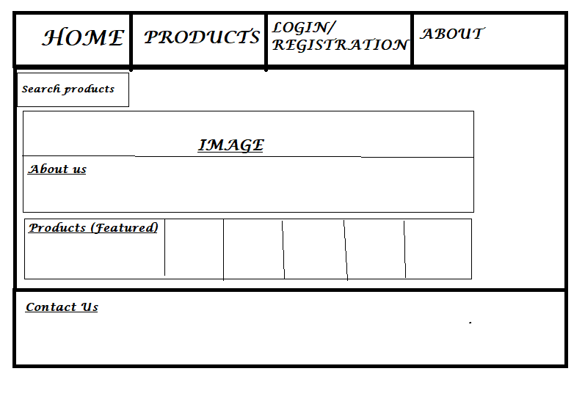

Fig 4.1.1 Mainpage

**4.1.2 Login and Registration Page** :

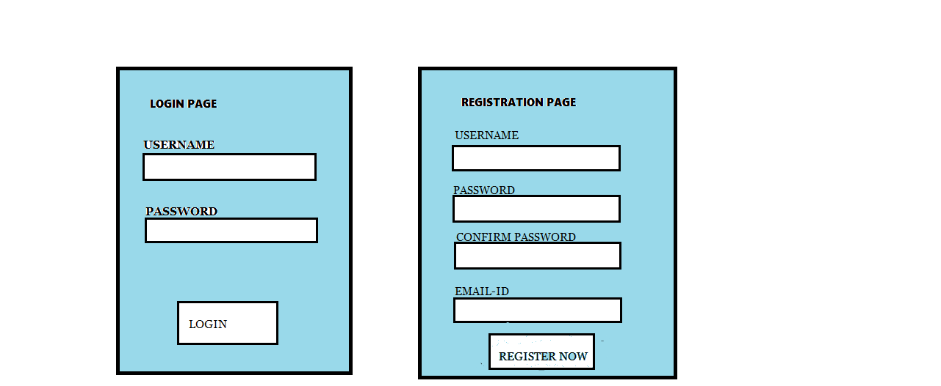

Fig 4.1.2 Login and Registration Page

**4.1.3 Buyer Page:**

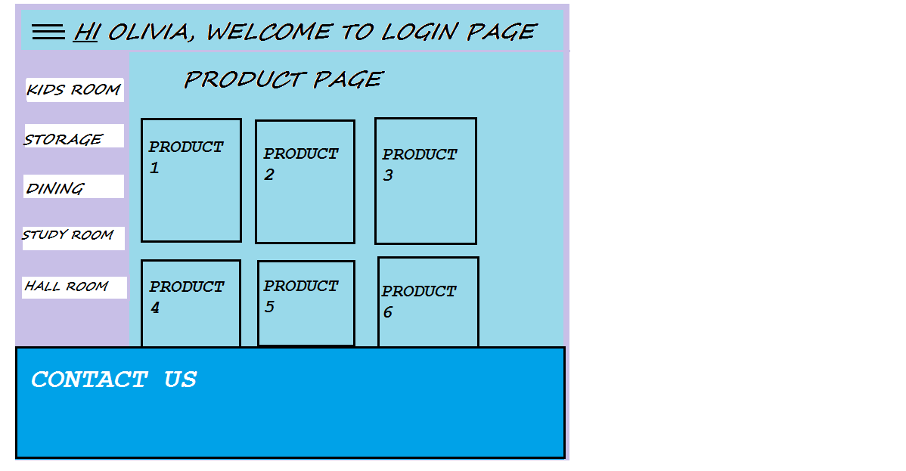

Fig 4.1.3 Buyer Page

**4.1.4 Product Description :**

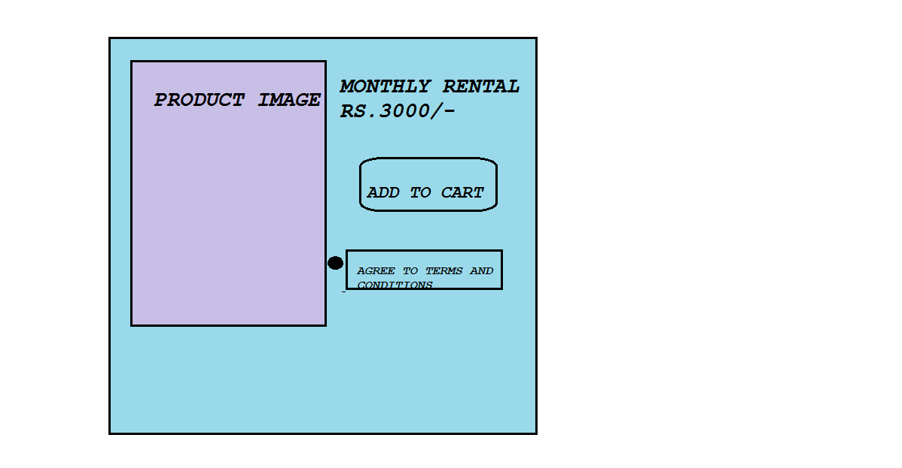

Fig 4.1.4 Product Description Page

**4.1.5 Billing page:**

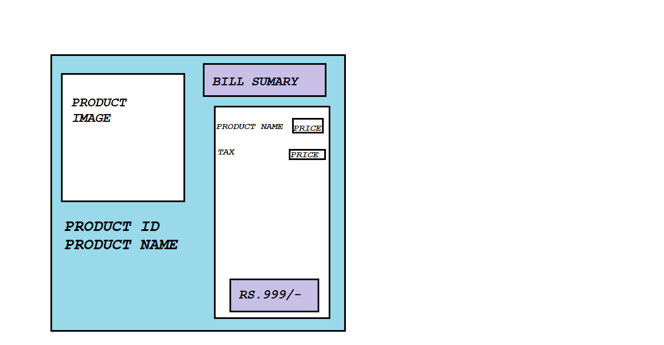  
 Fig 4.1.5 Billing Page

**4.2 Code design for Responsive web design:**

@media screen and (max-width: 600px) {

.topnav a:not(:first-child) {display: none;}

.topnav a.icon {

float: right;

display: block;

}

}

@media screen and (max-width: 600px) {

.topnav.responsive {position: relative;}

.topnav.responsive .icon {

position: absolute;

right: 0;

top: 0;

}

.topnav.responsive a {

float: none;

display: block;

text-align: left;

font-size: 12px;

}

**4.3 RIA design using AJAX:**

<script src="https://code.jquery.com/jquery-1.12.4.min.js"></script>

<script type="text/javascript">

$(document).ready(function(){

$('.search-box input[type="text"]').on("keyup input", function(){

/* Get input value on change */

var inputVal = $(this).val();

var resultDropdown = $(this).siblings(".result");

if(inputVal.length){

$.get("backend-search.php", {term: inputVal}).done(function(data){

// Display the returned data in browser

resultDropdown.html(data);

});

} else{

resultDropdown.empty();

}

});

// Set search input value on click of result item

$(document).on("click", ".result p", function(){

$(this).parents(".search-box").find('input[type="text"]').val($(this).text());

$(this).parent(".result").empty();

});

});

</script>

**Chapter 5**

**DATABASE DESIGN AND CONNECTIVITY**

**5.1 Database Table Design**

|  |  |  |  |  |  |  |
| --- | --- | --- | --- | --- | --- | --- |
| product_id | category | title | price | description | Image | Keywords |

Table 5.1.1 Products Table

|  |  |  |
| --- | --- | --- |
| product_id | ip_add | qty |

Table 5.1.2 Cart Table

|  |  |
| --- | --- |
| cat_id | cat_name |

Table 5.1.3 Category Table

|  |  |  |  |  |  |  |
| --- | --- | --- | --- | --- | --- | --- |
| cust_id | cust_ip | name | email | pass | Contact | Address |

Table 5.1.4 Customer Table

|  |  |  |  |
| --- | --- | --- | --- |
| username | password | confirmpassword | Email |

Table 5.1.5 Login Table

|  |  |
| --- | --- |
| username | password |

Table 5.1.6 Admin Table

**5.2 Database Connectivity**

<?php

$dbhost = 'localhost';

$dbuser = 'root';

$dbpass = 'password';

$conn = mysql_connect($dbhost, $dbuser, $dbpass);

if(! $conn ) {

die('Could not connect: ' . mysql_error());

}

$sql = 'SELECT detail,price FROM images where id =4';

mysql_select_db('olivia');

$retval = mysql_query( $sql, $conn );

if(! $retval ) {

die('Could not get data: ' . mysql_error());

}

while($row = mysql_fetch_array($retval, MYSQL_ASSOC)) {

echo

"{$row['detail']} <br> "."Rent: {$row['price']} <br> "

;

}

?></div>

**Chapter 6**

**IMPLEMENTATION DETAILS**

**6.1 Snapshots**

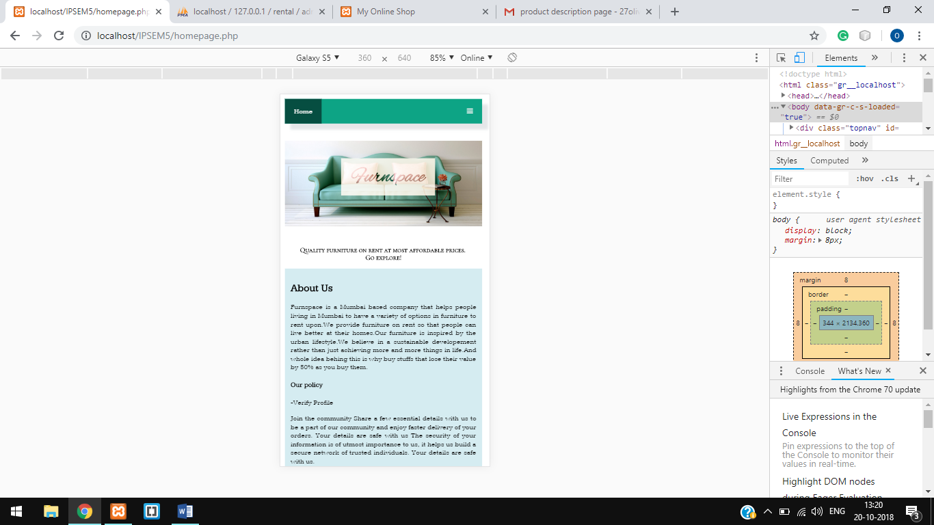

Fig 6.1.1Homepage

Responsive Homepage containing details of the website and products on display with Login button.

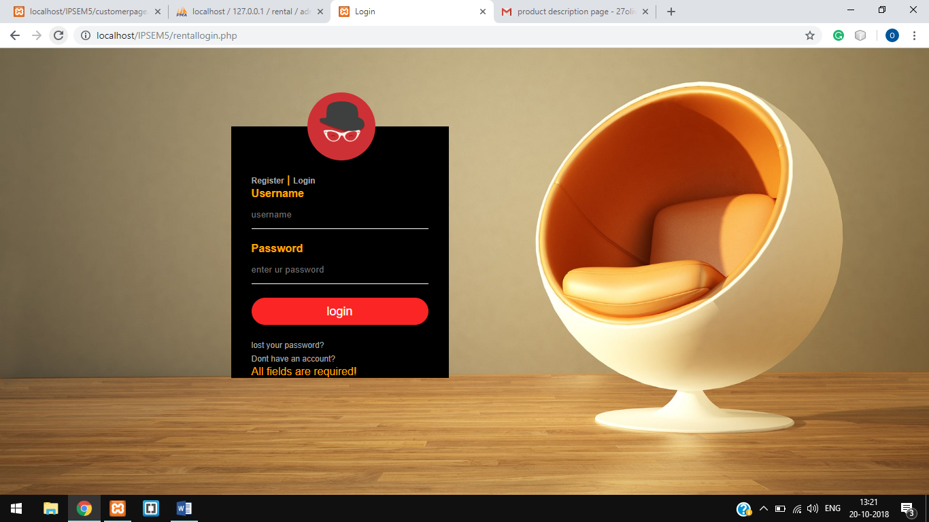

Fig 6.1.2 Login Page

Registered user can login by entering their username and password with a forgot password option.

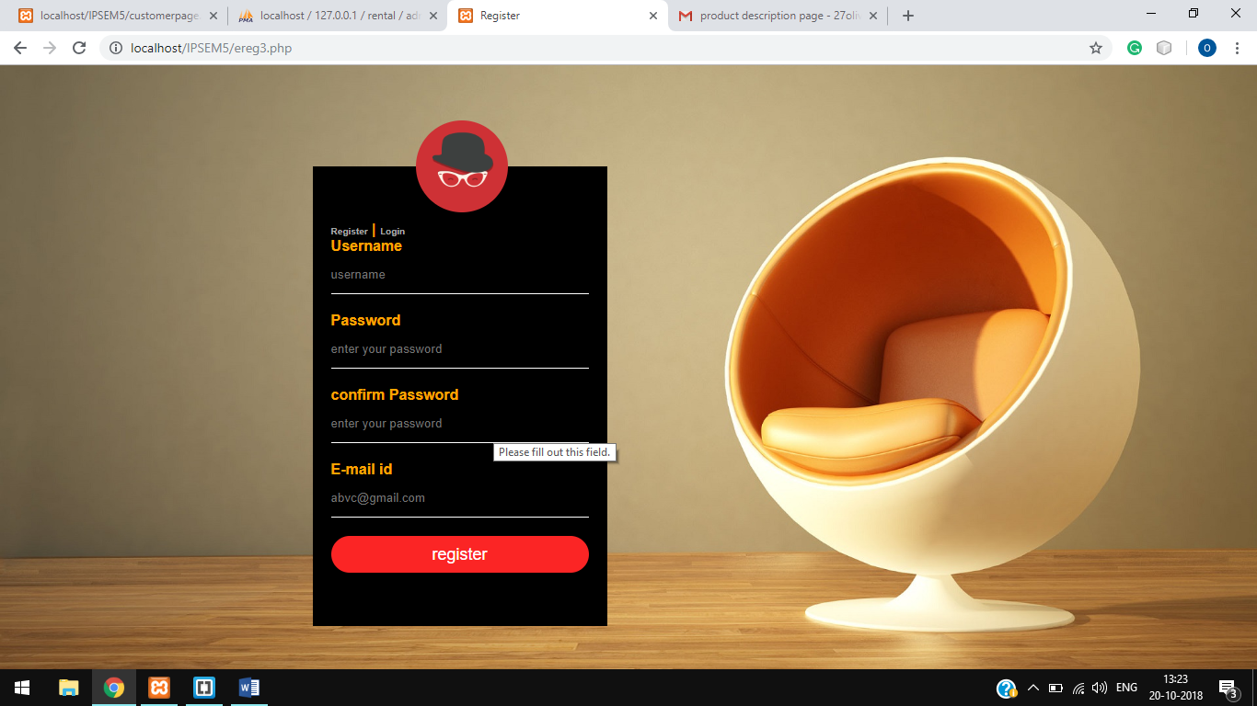

Fig 6.1.3 Registration Page

New users can register themselves by creating username,password and entering valid email_id as the website verifies for the syntax of the email_id entered.

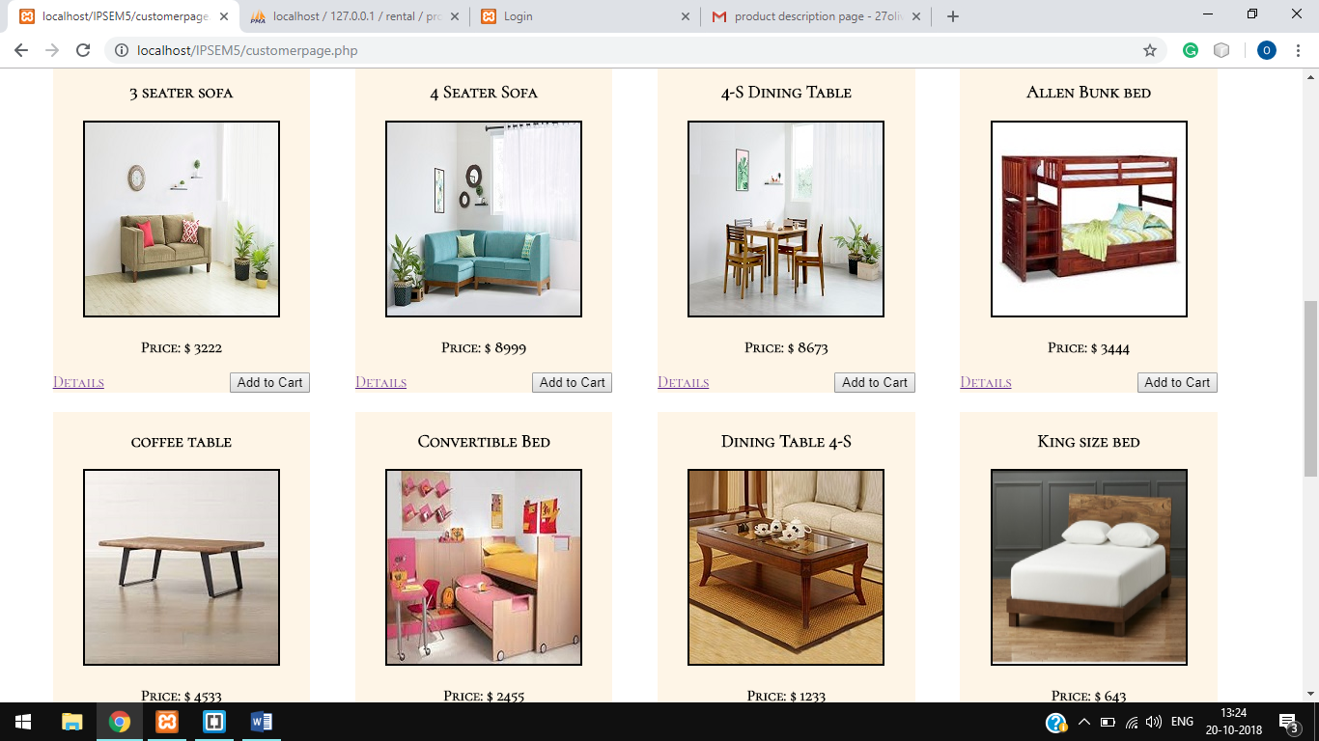

Fig 6.1.4 Products Page

The page contains all the featured products of the website containg the image,price,details and add to cart button.

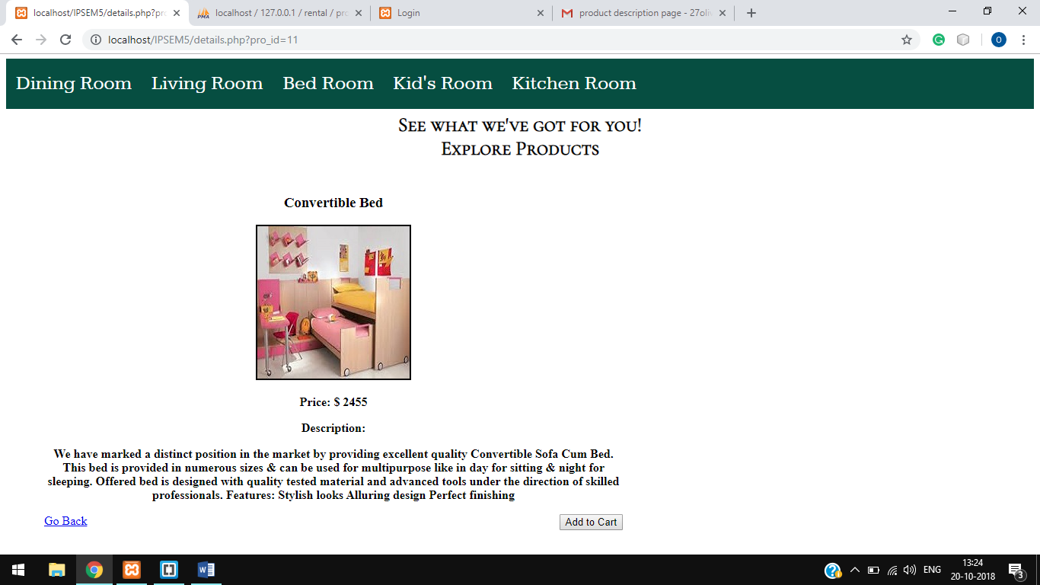

Fig 6.1.5 Product Description Page

Contains detailed description about the product and with navigation bar,go back and add to cart button.

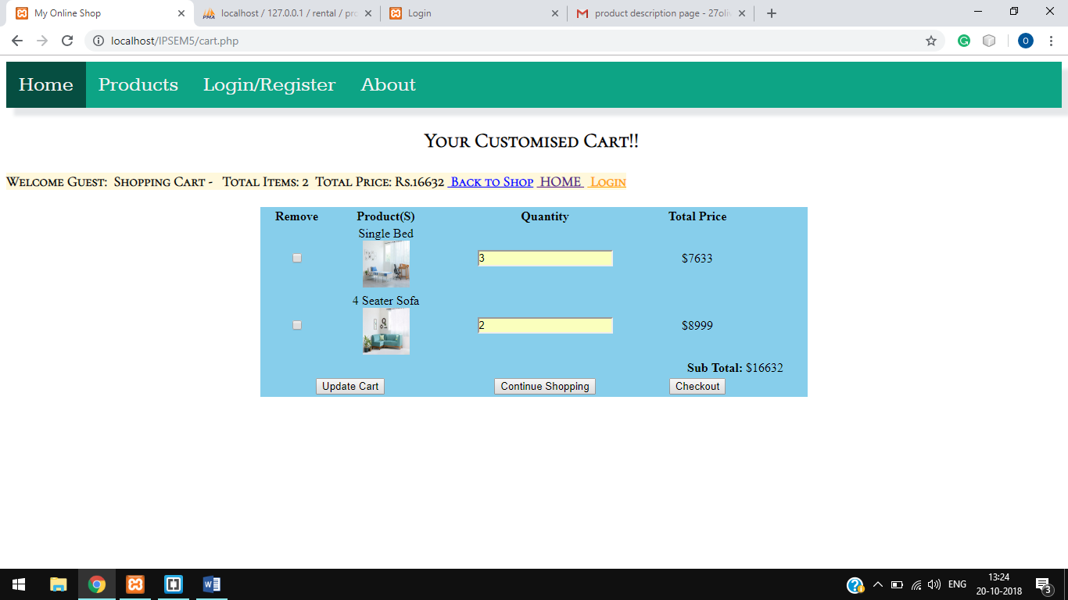

Fig 6.1.6 Billing Page

Billing page allows user to view their cart in which they have added products,allows user to update quantity and generates sub total amout with update cart,continue shopping and checkout buttons.

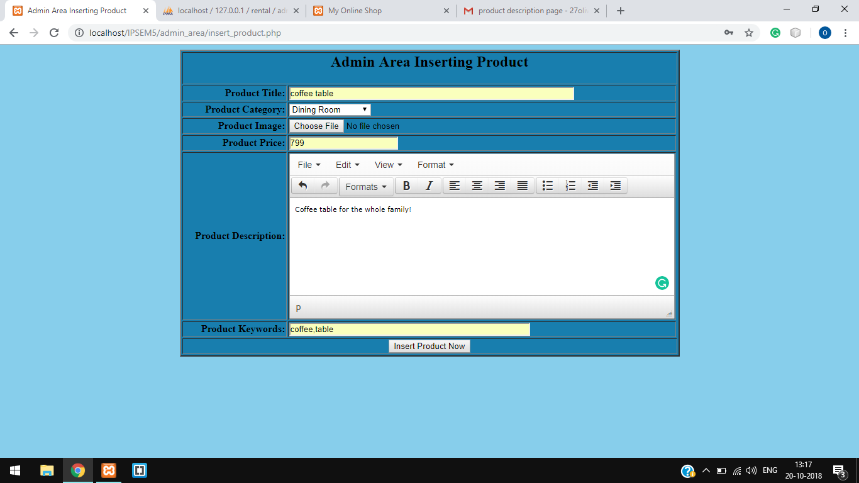

Fig 6.1.7 Admin Product Insertion Page

Admin can add new products through this page,it asks for product title,category,image,price,description and keywords with insert product now button.

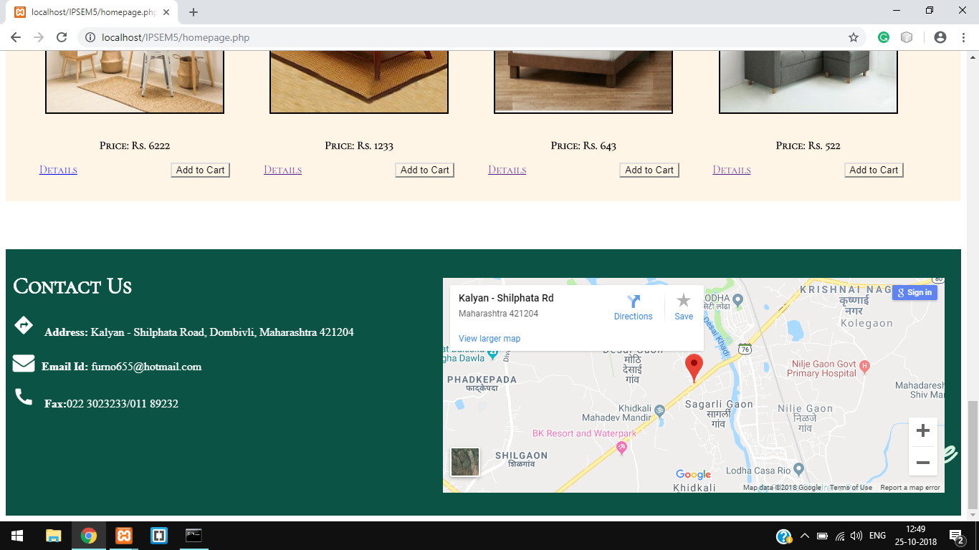Fig 6.1.8 Iframe

Customers can locate their address on the map to check for the availability of the products.

**Chapter 7**

**TESTING**

**7.1 HTML form validation**

<form action="" method="POST" action="<?php echo htmlspecialchars($_SERVER["PHP_SELF"]);?>">

<p>Username</p>

<input type="text"name="user" placeholder="username" required>

<script type="text/javascript">

</script>

<p> Password</p>

<input type =password name="pass1" id="pass1" placeholder="enter your password" pattern="(?=.*\d)(?=.*[a-z])(?=.*[A-Z]).{8,}" title="Must contain at least one number and one uppercase and lowercase letter, and at least 8 or more characters" required>

<p> confirm Password</p>

<input type =password name="pass2" id="pass2" placeholder="enter your password" required>

<div id="message">

<h6>Password must contain the following:Lower case,Capital letter,Number,Minimum 8 characters</h6>

<p id="letter" class="invalid"> </p>

<p id="capital" class="invalid"> </p>

<p id="number" class="invalid"> </p>

<p id="length" class="invalid"> </p>

</div>

<script>

var myInput = document.getElementById("pass1");

var letter = document.getElementById("letter");

var capital = document.getElementById("capital");

var number = document.getElementById("number");

var length = document.getElementById("length");

// When the user clicks on the password field, show the message box

myInput.onfocus = function() {

document.getElementById("message").style.display = "block";

}

// When the user clicks outside of the password field, hide the message box

myInput.onblur = function() {

document.getElementById("message").style.display = "none";

}

// When the user starts to type something inside the password field

myInput.onkeyup = function() {

// Validate lowercase letters

var lowerCaseLetters = /[a-z]/g;

if(myInput.value.match(lowerCaseLetters)) {

letter.classList.remove("invalid");

letter.classList.add("valid");

} else {

letter.classList.remove("valid");

letter.classList.add("invalid");

}

// Validate capital letters

var upperCaseLetters = /[A-Z]/g;

if(myInput.value.match(upperCaseLetters)) {

capital.classList.remove("invalid");

capital.classList.add("valid");

} else {

capital.classList.remove("valid");

capital.classList.add("invalid");

}

// Validate numbers

var numbers = /[0-9]/g;

if(myInput.value.match(numbers)) {

number.classList.remove("invalid");

number.classList.add("valid");

} else {

number.classList.remove("valid");

number.classList.add("invalid");

}

// Validate length

if(myInput.value.length >= 8) {

length.classList.remove("invalid");

length.classList.add("valid");

} else {

length.classList.remove("valid");

length.classList.add("invalid");

}

}

</script>

<p>E-mail id</p>

<input type="email" name="email" placeholder="abvc@gmail.com">

<input type="submit" name="submit" name="" value="register" onsubmit="validateemail()" onclick="return Validate12()" >

<script>

function validateemail()

{

var x=document.myform.email.value;

var atposition=x.indexOf("@");

var dotposition=x.lastIndexOf(".");

if (atposition<1 || dotposition<atposition+2 || dotposition+2>=x.length){

alert("Please enter a valid e-mail address \n atpostion:"+atposition+"\n dotposition:"+dotposition);

return false;

}

}

</script>

<script type="text/javascript">

function Validate12() {

var password = document.getElementById("pass1").value;

var confirmPassword = document.getElementById("pass2").value;

if (password != confirmPassword) {

alert("Passwords do not match.");

return false;

}

return true;

}

</script>

</form>

**7.2 Website Security testing for SQL injection**

if(!empty($_POST['user']) && !empty($_POST['pass1']) && !empty($_POST['pass2']) && !empty($_POST['email'])) {

$user= mysqli_real_escape_string($con,$_POST['user']);

$pass1=mysqli_real_escape_string($con,$_POST['pass1']);

$pass2=mysqli_real_escape_string($con,$_POST['pass2']);

$email=mysqli_real_escape_string($con,$_POST['email']);

}

$query=mysqli_query($con,"SELECT * FROM login WHERE username='".$user."'");

$numrows=mysqli_num_rows($query);

if($numrows==0)

{

$sql="INSERT INTO login(username,password,confirmpassword,email) VALUES('$user','$pass1','$pass2','$email')";

**Chapter 8**

**WEBSITE LAUNCHING**

**Steps for website launching:**

1. Select and register a domain name.
2. Find, choose and purchase web hosting.
3. Make a backup copy of your website files.
4. Strive to make your website easy to navigate.
5. Validate your code.
6. Implement a site map.
7. Test your website in a variety of web browsers.
8. Ensure that you're using SEO-friendly code.
9. Install website analytics to keep track your website's success and current status.

Transfer your website's files to your web host.

**Chapter 9**

**CONCLUSION AND FUTURE SCOPE**

**Conclusion:**

We have successfully accomplished in implementing our proposed idea.Our website provides a wide range of furniture products for every room in home be it living,dining or bedroom.It allows user to choose among the products and rent it at a very cheap rate for a specified period of time.Users can add products in their cart and save .Customers can avail our special service of free installation, and returning.

Moreover,there is an admin login page wherein the admin can login to add,update or remove products and also category of products.The website is responsive i.e. the images,style constraints differ according to the device it is viewed in.

**Future Scope:**

In future we aim to take this website further more advance by adding more products,making it more user friendly by adding such styles,cookies so that we can track the customers interest and provide them a better range of those interest based products and chat box by which the customers can directly interact with the admin and clear their doubts.

We would also like to develop an app of our website for better personalization,ease of sending notifications and scanning of bar code to verify products.

**Chapter 10**

**APPENDIX I:CODE SAMPLE**

/*ABOUT THE WEBSITE ANS IT’S POLICY*/

<section>

<div id="about">

<h1> About Us</h1>

<p>Furnspace is a Mumbai based company that helps people living in Mumbai to have a variety of options in furniture to rent upon.We provide furniture on rent so that people can live better at their homes.Our furniture is inspired by the urban lifestyle.We believe in a sustainable developement rather than just achieving more and more things in life.And whole idea behing this is why buy stuffs that lose their value by 50% as you buy them.

<h4>Our policy</h4>

<p>-Verify Profile</p> <p>

Join the community

Share a few essential details with us to be a part of our community and enjoy faster delivery of your orders.

Your details are safe with us

The security of your information is of utmost importance to us, it helps us build a secure network of trusted individuals. Your details are safe with us.</p>

<p>-Pay refundable Deposits</p><p>

Bespoke products to suit your needs!

With tenures starting at just 3 months.Pay the deposit at start and collect while return.</p>

<p>-Pay at once</p><p>

The furnitures are specified with the tenure at which they can be rented.But you can always rent it again once your tenure is over.

You just have to pay the whole amount at the start of the tenure.The best thing is our staff woould come install furniture and while returning disassemble and recollect the furniture from your place itself.</p><p>*All terms and conditions applied.</p>

</p>

</div>

</section>

<section>

<div id="about">

<h1> Why We?</h1>

<p>Furnspace provided an end to end furnishing products.Customers need not worry about the quality of the product at all.

Not just that we provide services and installation of furniture for free.We provide you with furnitures for every room,every nook and corner of your house.</p>

</p>

</div>

</section>

/*RESPONSIVE*/

@media screen and (max-width: 600px) {

.topnav a:not(:first-child) {display: none;}

.topnav a.icon {

float: right;

display: block;

}

}

@media screen and (max-width: 600px) {

.topnav.responsive {position: relative;}

.topnav.responsive .icon {

position: absolute;

right: 0;

top: 0;

}

.topnav.responsive a {

float: none;

display: block;

text-align: left;

font-size: 12px;

}

.topnav a{

font-size: 12px;

}

#intro{

font-size: 12px;

}

#about{

font-size: 12px;

}

footer h1{

font-size: 12px;

}

.textfooter{

font-size: 12px;

}

footer p{

font-size: 12px;

}

}

/*RESPONSIVE CODE ENDS HERE!*/

**ACKNOWLEDGEMENT**

We would like to express special thanks of gratitude to our guide **Asst. Prof. Kalpana Wani** who gave us the golden opportunity to do this wonderful project on the topic of **Online Rental System,**which helped us in doing a lot of research and we came to know about so many new things.We would also like to thank our HOD **Dr. H.K. Chavan** for providing us the opportunity to implement our project.We are really thankful to them.Finally we would also like to thank our parents and friends who helped us a lot in finalizing this project within the limited time frame.

1. Ayrin George(501609)

2. Tanvi Dhakate(501612)

3. Olivia Biswas(501638)

**REFERENCES**

* <https://codepen.io/ehermanson/pen/KwKWEv>
* <https://dev.to/skptricks/ajax-search-box-in-php-mysql-and-jquery-1a32>
* <https://www.phpjabbers.com/how-to-prevent-sql-injection-with-php-php71.html>
* <https://www.udemy.com/php-mysql-tutorial/>
* <https://www.w3schools.com/>
* “Learning php 5”,David Sklar,O’Reilly Publications
* “Web Technologies:Black Book”,Dreamtech publications
* [www.tutorialspoint.com](http://www.tutorialspoint.com/)
* [www.stackoverflow.com](http://www.stackoverflow.com/)